Software Requirements Specification

Owner: Abdulrahman Status: Done Version: 1.0 Date: 24-Sep

Project Idea
This project is a web-based Task Management System where users can create and manage projects and organize the work needed within each project.
A user can create a project and become its administrator. The administrator can add other users as members of the project and manage their access. Project members can view the project and work on tasks assigned to them.
Each project contains a set of tasks. Tasks can have information such as a title, description, status, priority, due date, and assigned member. Users can create, update, and manage tasks according to their role in the project.
The main goal of the system is to provide a simple way for small teams to organize projects and track their work in one place.

Project Scope

In Scope
The system will provide the following core functionality:
- User registration (Sign in) and login.
- Creating and managing projects.
- Assigning a project administrator (Only one per project).
- Adding and removing members from projects.
- Managing project membership and basic roles.
- Creating, editing, viewing, and deleting tasks within a project. (CRUD)
- Assigning tasks to project members.
- Setting task status, priority, and due dates.(Cut)
- Viewing tasks belonging to a project.
- Restricting project actions based on the user's role.

Out of Scope
To keep the project focused on learning the fundamentals, the first version will not include advanced features such as:
- Real-time chat or messaging.
- Video or voice meetings.
- File storage and advanced document management.
- Complex project planning such as Gantt charts.
- Advanced analytics and reporting.
- Notifications through email, SMS, or push messages.
- Third-party integrations.
- AI-generated tasks or project management features.
- Highly advanced permission systems.

Main Project Boundary
The first version will focus on one central workflow:
User → Project → Members → Tasks
The project will be designed around this model, with additional features added only when they support the core task-management functionality.

Visual Draft:

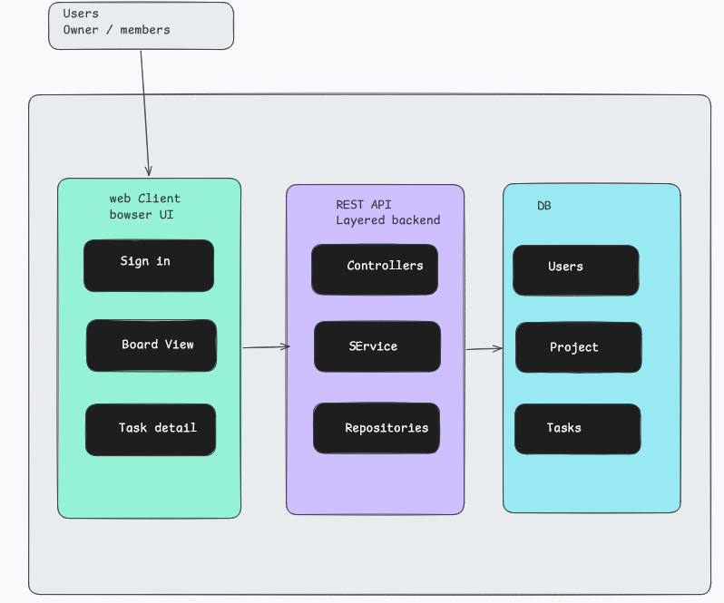

Actors

Definition:
An actor is external. External nature: Actors always exist outside the boundary of the system being designed.

Note: It is a Role, not a person: An actor defines a specific role rather than a specific individual. One person might act as multiple actors, and multiple people can share the same actor role.

1. Guest:
A person who is not logged in and can access functions such as signing in and creating a new account.

2. Authenticated User:
A person who is logged in and can access and manage existing projects and create new ones.

2.1. Project Member:
An authenticated user participating in a project without administrative control over the project.

2.1.1 Project Admin:
An authenticated user with administrative control over the project.

Business Rules (BR)
82BRs

1. User & Account Rules
BR-01: Each authenticated user account must have a unique email address.
BR-02: A user's email address cannot be changed after the account is created.
BR-03: A user's name can be changed by the user.
BR-76: Account names, project names, and task titles must not be empty and must not exceed 35 characters.
BR-77: Account names, project names, and task titles may contain only letters, digits (0–9), underscores (_), and spaces. A value made up only of spaces counts as empty under BR-76.
BR-04: A user may create zero or more projects.
BR-05: A user may be a member of zero or more projects.
BR-06: A user may delete their account after completing the required confirmation process.
BR-07: Deleting a user account removes the user's personal account data.
BR-08: A user cannot access protected system functionality without being authenticated.

2. Authentication Rules
BR-09: A user may authenticate through Google OAuth.
BR-10: If successful Google authentication matches an existing account, the user is authenticated into that account.
BR-11: If successful Google authentication matches an email that has no existing account, a new user account is created.
BR-12: If Google authentication fails or is cancelled, no new account is created.
BR-71: After a successful authentication, the authenticated user is redirected to the main page.
BR-73: When an authenticated user logs out, their authenticated session is terminated.
BR-74: After logging out, the user must authenticate again before accessing functionality that requires authentication.
BR-80: "A Guest may register with an email address and a password. Registration(Sign in) creates an account only if the email is not already associated with an existing account (BR-01)."
BR-81: "A password must be at least 8 characters long.
BR-82: "If email/password sign-in fails, the system shows a generic error that does not reveal whether the email or the password was incorrect, and no session is created."

3. Project Rules
BR-13: A project must have a non-empty name.
BR-14: A project must have exactly one Project Admin while the project exists.
BR-15: The user who creates a project automatically becomes its Project Admin.
BR-16: A project may have one or more members.
BR-17: A Project Admin is also a member of the project.
BR-18: A user cannot be added to a project if they are already a member of that project. A user who has previously left or been removed from the project may be added again.
BR-19: A user can only access a project if they are a member of that project.
BR-20: A Project Admin may rename their project.
BR-21: Only the Project Admin may delete the project.
BR-22: Deleting a project permanently deletes the project and all tasks belonging to it.
BR-72: Pinned project appears on top of the project list.

4. Project Membership Rules
BR-23: Only an existing registered user can be added as a project member.
BR-24: Only the Project Admin can add members to a project using their email address.
BR-25: Only the Project Admin can remove another member from a project.
BR-78: A Project Admin cannot remove themselves from a project using the member-removal operation.
BR-26: A Project Admin cannot leave a project before selecting a successor unless he was the only member of the project.
BR-75: A user cannot delete their account while they are a Project Admin of any project unless the required conditions for leaving or deleting each project have been fulfilled.
BR-27: A Project Member may voluntarily leave a project.
BR-28: When a member leaves or is removed, they lose access to the project.
BR-29: When a member leaves or is removed, they are removed from all task-assignee relationships within that project. (duplication with BR-60)
BR-30: Removing a member does not delete tasks that were previously assigned to that member.

5. Project Admin Transfer Rules
BR-31: A project must always have exactly one Project Admin while the project exists.(duplication with BR-14)
BR-32: A Project Admin who leaves a project containing other members must select a successor from the project's existing members.
BR-33: The successor must already be a member of the project.(delete)
BR-34: The successor becomes the Project Admin before the previous Admin is removed from the project.
BR-35: After transferring administration, the previous Admin becomes a regular Project Member until they leave.
Note: Before the Admin becomes a member, remove all the assignments from it, as the admin can hold up to 5 Tasks while a member can hold up to 3.
BR-36: If the Project Admin is the only member of a project, leaving the project permanently deletes the project and its tasks.

6. Task Rules
BR-37: Every task must belong to exactly one project.
BR-38: A project may contain zero or more tasks.
BR-39: Every task must have a non-empty title.
BR-40: A task may have a description.
BR-41: A task may have a due date.
BR-42: A task may have zero or more assignees.
BR-43: A task can have multiple assignees.
BR-44: A task's assignees must be members of the task's project.
BR-45: A task cannot be assigned to a user who is not a member of its project.(duplication BR-44)

7. Task Creation & Modification Rules
BR-46: Only the Project Admin can create tasks.
BR-47: The Project Admin can edit a task's title, description, and due date.
BR-48: A task title cannot be changed to an empty value.
BR-49: A Project Member can edit the description and due date of a task only when they are assigned to that task.
BR-50: A Project Member cannot edit the title of a task.
BR-51: A Project Member cannot edit a task to which they are not assigned.(duplication BR-49)
BR-52: Changes to task information and status must be visible to authorized project members after being saved.

8. Task Assignment Rules
BR-53: Only the Project Admin can assign members to tasks.
BR-54: Only the Project Admin can remove members from tasks.
BR-55: Project Members cannot assign themselves to tasks. (included in BR-53)
BR-56: An assignee must be a member of the task's project. (duplicate with BR-44 )
BR-57: A regular Project Member cannot be assigned to more than 3 tasks within the same project.
BR-58: A Project Admin cannot be assigned to more than 5 tasks within the same project.
BR-59: Removing an assignee is only valid when that user is currently assigned to the task.
BR-60: When a member leaves or is removed from a project, all of their task assignments within that project are removed.

9. Task Deletion Rules
BR-61: Only the Project Admin can delete a task.
BR-62: Task deletion requires confirmation.
BR-63: Deleting a task permanently removes its assignee relationships.(What does “ assignee relationships”?)

10. Task Status
BR-64: A task MUST be in a state that indicates its current state.
BR-65: A Project Member can change a task's status to any allowed status only if they are assigned to it.
BR-66: A Project Member cannot change a task's status to one to which they are not assigned.(duplication BR-65)
BR-67: A Project Admin can change the status of any task within their project.
BR-68: Changing a task's status does not remove its assignee relationships.
BR-69: A task remains visible to project members regardless of its status.
BR-70: A task must have one of the following statuses: Open, In Progress, or Closed.
BR-79: A newly created task starts as “Open”

Functional Requirements (FR)
62FRs

Guest (Google Authentication)
FR-01: The system shall provide Google Authentication and basic registration (Sign in) (Email/password) for Guest users. (US-1) [subject to BR-01, BR-09]
FR-02: The system shall redirect the Guest to Google's OAuth authentication flow when Google sign-in is initiated. (US-1) [subject to BR-09]
FR-03: The system shall create an account when authentication succeeds for a Google email address that is not associated with an existing account.(US-1) [subject to BR-01, BR-11]
FR-04: The system shall authenticate the existing account when the authenticated Google email address is already associated with an existing account.(US-1) [subject to BR-01, BR-10]
FR-05: The system shall not create an account when Google authentication fails or is cancelled and shall keep the Guest on the sign-in screen. (US-1) [subject to BR-12]
FR-06: The system shall automatically sign in the user and redirect them to their dashboard after successful account creation. (US-2) [subject to BR-71]
FR-58: "The system shall allow a Guest to sign-in with a name, email address, and password, shall create the account only when the email is not already associated with an account and the input is valid, and shall otherwise keep the Guest on the registration (Sign in) screen. (US: none) [subject to BR-01, BR-76, BR-77, BR-80, BR-81]"
FR-59: "The system shall authenticate a Guest who signs in with a valid email and password, and on failure shall show a generic error, keep the Guest on the sign-in screen, and create no session. (US: none) [subject to BR-71, BR-82]"

Authenticated User
FR-07: The system shall display the authenticated user's project list on the main dashboard.(US-2)

Account Management
FR-08: The system shall allow the user to view their account details by clicking the profile icon and shall route the user to Account Settings where their current Name and Email are displayed. (US-5) [subject to BR-01]
FR-09: The system shall allow the user to modify their profile name and save the change. (US-5) [subject to BR-03]
FR-10: The system shall not allow the user to modify their email address. (US-5) [subject to BR-02]
FR-11: The system shall allow the user to log out and end their session and shall redirect the user to the sign-in screen after logout. (US-6) [subject to BR-73, BR-74]
FR-12: The system shall allow the user to delete their account only after a required confirmation step. (US-7) [subject to BR-06 , BR-07]
FR-13: Upon confirmed account deletion, the system shall permanently delete the user's account and personal account data. (US-7) [subject to BR-06, BR-07]
FR-61: The system shall allow the user to change their password.

Project Management
FR-14: The system shall allow an Authenticated User to create a project.(US-4) [subject to BR-04, BR-13]
FR-15: The system shall automatically make the user who created the project the Project Admin.(US-4) [subject to BR-14, BR-15, BR-17]
FR-16: The system shall not allow a user to create a project without a name.(US-4) [subject to BR-13]
FR-17: The system shall allow the Project Admin to rename the project only when the new name is non-empty, and shall reflect the new name immediately for all project members. (US-22) [subject to BR-20]
FR-18: The system shall prevent users from creating or updating account names, project names, or task titles that are empty, exceed 35 characters, or contain characters other than letters, digits (0–9), underscores (), and spaces . (US-04, US-13) [subject to BR-76, BR-77]
FR-19: The system shall allow the Project Admin to delete the project after confirmation. Upon confirmation, the system shall permanently delete the project and all tasks belonging to it and display a success or failure message. (US-11) [subject to BR-21, BR-22, BR-62]
FR-62: The system shall automatically remove all project members from the project when the Project Admin deletes the project.
FR-20: The system shall allow an Authenticated User to pin and unpin projects. (US-3) [subject to BR-72]
FR-21: The system should display pinned projects at the top of the user's project list. (US-3) [subject to BR-72]
FR-22: The system should indicate which projects are pinned.(US-3)
FR-23: The system should immediately update the project list when a project is unpinned. (US-3)
FR-24: The system shall permanently delete a project and all of its tasks when the Project Admin is the sole member and leaves the project. (US-16) [subject to BR-36]
FR-25: The system shall display a success or failure message after a Project Admin successfully leaves a project or the leave operation fails. (US-16)
FR-60: The system shall allow the Project Admin to transfer the admin role to another project member, regardless of whether the current Project Admin leaves the project or remains a member.

Project Members
FR-26: The system shall allow the Project Admin to add members to the project using their email address. Only if the email belongs to an existing registered user, and shall prevent duplicate membership, and shall display a success or failure message. (US-10) [subject to BR-18, BR-23, BR-24]
FR-27: The system shall allow the Project Admin to remove a member from the project. It shall display a success or failure message. (US-9) [subject to BR-25, BR-78 ]
FR-28: The system shall allow Project Members to view the project's member list.(US-17) [subject to BR-19]
FR-29: The system shall allow a Project Member to leave a project and, after leaving, shall remove the member from the project member list, revoke project access, and remove their task-assignee relationships. (US-19) [subject to BR-27, BR-28, BR-29]
FR-30: The system shall prevent a Project Member from removing another member from the project. (US-19)
FR-31: The system shall not allow the Project Admin to leave a project before a successor Admin is selected from among the current project members, when other members remain. (US-16) [subject to BR-31, BR-32, BR-33]
FR-32: The system shall transfer the Admin role to the selected successor before removing the previous Admin from the project, and shall change the previous Admin's role to Project Member. (US-16) [subject to BR-32, BR-33, BR-34, BR-35]
FR-33: The system shall not allow the Project Admin to delete their account before a successor Admin is selected from among the current project members when other members remain.(US-7) [subject to BR-06, BR-31, BR-32, BR-33]
FR-34: The system shall retain tasks previously assigned to a removed member while removing that member from the assignee list of those tasks. (US-9) [subject to BR-29, BR-30]

Task Management — Project Admin
FR-35: The system shall allow the Project Admin to create tasks within the project. (US-13) [subject to BR-37, BR-38, BR-46]
FR-36: The system shall not allow the Project Admin to create a task without a title. (US-13) [subject to BR-39, BR-46]
FR-37: The system shall display a newly created task in the project's task list or board after successful creation. (US-13)
FR-38: The system shall allow the Project Admin to edit a task's details, including its title, description, and due date, and shall not allow the title to be changed to an empty value. (US-14) [subject to BR-40, BR-41, BR-47, BR-48]
FR-39: The system shall remove all assignee associations associated with the deleted task. (US-15) [subject to BR-61, BR-62, BR-63]
FR-40: The system shall allow the Project Admin to change the status of any task in the project. (US-21) [subject to BR-64, BR-67, BR-70]
FR-41: The system shall allow only the Project Admin to assign project members to tasks, provided that each assignee is a current member of the project. (US-12) [subject to BR-53, BR-54, BR-56]
FR-42: The system shall allow a task to have more than one assignee. (US-12) [subject to BR-42, BR-43]
FR-43: The system shall allow a task to have zero assignees. (US-13) [subject to BR-42]
FR-44: The system shall prevent a regular Project Member from being assigned to more than 3 tasks within the same project and shall prevent the Project Admin from being assigned to more than 5 tasks within the same project. (US-12) [subject to BR-57, BR-58]
FR-45: The system shall allow only the Project Admin to remove an assignee from a task when that member is currently assigned to the task. (US-12) [subject to BR-54, BR-59]

Task Management — Project Member
FR-46: The system shall allow Project Members to view all tasks within the project. (US-17) [subject to BR-19]
FR-47: The system shall allow Project Members to edit and control only the tasks assigned to them.(US-18) [subject to BR-51]
FR-48: The system shall allow a Project Member to edit the description of a task assigned to them. (US-18) [subject to BR-49, BR-51]
FR-49: The system shall allow a Project Member to edit the due date of a task assigned to them. (US-18) [subject to BR-49, BR-51]
FR-50: The system shall not allow a Project Member to edit a task's title. (US-18) [subject to BR-50]
FR-51: The system shall allow a Project Member to change the status of a task assigned to them. (US-21) [subject to BR-65]
FR-52: The system shall not allow a Project Member to change the task’s status of a task that is not assigned to them.(US-21) [subject to BR-66]

Task Status
FR-53: The system shall maintain task status using the allowed statuses Open, In Progress, and Closed. (US-21) [subject to BR-64, BR-70]
FR-54: The system shall keep tasks visible to project members regardless of their status and shall preserve their assignee associations when their status changes. (US-21) [subject to BR-68, BR-69]
FR-55: The system shall immediately reflect saved task-information and task-status changes to authorized project members viewing the task. (US-14, US-18, US-21) [subject to BR-52]

Quick Actions
FR-56: The system should provide quick actions for Project Members, including pinning a project, unpinning a project, and leaving a project. (US-20)
FR-57: The system should provide the Project Admin with all Project Member quick actions, plus actions for renaming and deleting the project. (US-8)

Use Case Diagram

Use Case Description

Use Case | Actor | Description
Sign up | Guest | Allows a Guest to create a new account using the required registration (Sign in) information.
Sign In | Guest | Allows a Guest to authenticate using Google or email/password and access the system.
Manage Account | Authenticated User | Allows the user to view and update their account information, including their name and password. The email address cannot be changed.
View Projects | Authenticated User | Allows the user to view the projects they have access to.
View Dashboard | Authenticated User | Allows the user to access the main dashboard and view their project list.
Manage Pinned Projects | Authenticated User | Allows the user to pin or unpin projects.
Log Out | Authenticated User | Allows the user to securely log out of the system and end their session.
Create Project | Authenticated User | Allows the user to create a new project. The project name must not be empty, and the creator automatically becomes the Project Admin.
Delete Account | Authenticated User | Allows the user to permanently delete their account after confirmation.
View Members | Project Member | Allows a project member to view the members of the project.
View Tasks | Project Member | Allows a project member to view the tasks of the project.
Edit Task | Project Member / Project Admin | Allows the Project Member or Project Admin to edit task information. The Project Admin can edit the title, description, due date, and status. The Project Member can edit the description, due date, and status only for tasks they are assigned to, and cannot edit the title.
Leave Project | Project Member | Allows a project member to leave the project, lose access to it, and be removed from task-assignee relationships.
Delete Account | Project Member | Allows the Project Member to permanently delete their account. The member must leave their projects before the account is deleted.
Rename Project | Project Admin | Allows the Project Admin to rename the project. The new project name must not be empty.
Add Member | Project Admin | Allows the Project Admin to add an existing registered user to the project using their email address.
Remove Member | Project Admin | Allows the Project Admin to remove a member from the project. The removed member loses access to the project and is removed from task-assignee relationships, while the tasks remain.
Create Task | Project Admin | Allows the Project Admin to create a new task. The task title must not be empty, and the task starts with an Open status. Assignment is optional.
Assign Member To Task | Project Admin | Allows the Project Admin to assign one or more project members to a task. Members cannot assign themselves, and assignment limits apply.
Remove Assignee | Project Admin | Allows the Project Admin to remove a currently assigned member from a task.
Delete Task | Project Admin | Allows the Project Admin to permanently delete a task and its assignee relationships.
Delete Project | Project Admin | Allows the Project Admin to permanently delete the project, its tasks, and all project memberships, revoking members' access to the project.
Delete Account | Project Admin | Allows the Project Admin to permanently delete their account. Project administration rules must be handled before the account is deleted.
Leave Project | Project Admin | Allows the Project Admin to leave the project. If other members remain, the admin role must be transferred to another member. If the admin is the sole member, the project and its tasks are deleted.
Transfer Admin Role | Project Admin | Allows the Project Admin to transfer the admin role to another project member, whether the current admin leaves the project or remains a member.

Database Schema

1. Users
email VARCHAR(255) PK, NOT NULL
username VARCHAR(35) NOT NULL
password VARCHAR(255) NULL

2. Project
id INT PK, auto-generated
admin VARCHAR(255) FK → User.email, NOT NULL
title VARCHAR(35) NOT NULL
createdAt TIMESTAMP NOT NULL

3. ProjectMember
id INT PK, auto-generated
projectId INT FK → Project.id, NOT NULL
email VARCHAR(255) FK → User.email, NOT NULL
pinned BOOLEAN NOT NULL DEFAULT FALSE
joinedAt TIMESTAMP NOT NULL
UNIQUE(projectId, email)

4. Task
id INT PK, auto-generated
projectId INT FK → Project.id, NOT NULL
title VARCHAR(35) NOT NULL
description TEXT NULL
status VARCHAR(20) NOT NULL
dueDate DATE NULL
createdAt TIMESTAMP NOT NULL

5. TaskAssignee
Id INT PK, auto-generated
taskId INT FK → task.id
projectMemberId INT FK → projectMember.id
UNIQUE(taskId, projectMemberId)

Relationships
Users 1 ────────< Project
Users 1 ────────< projectMember >──────── 1 Project
Project 1 ─────< task
task 1 ───────< taskAssignee >──────── 1 projectMember

ERD

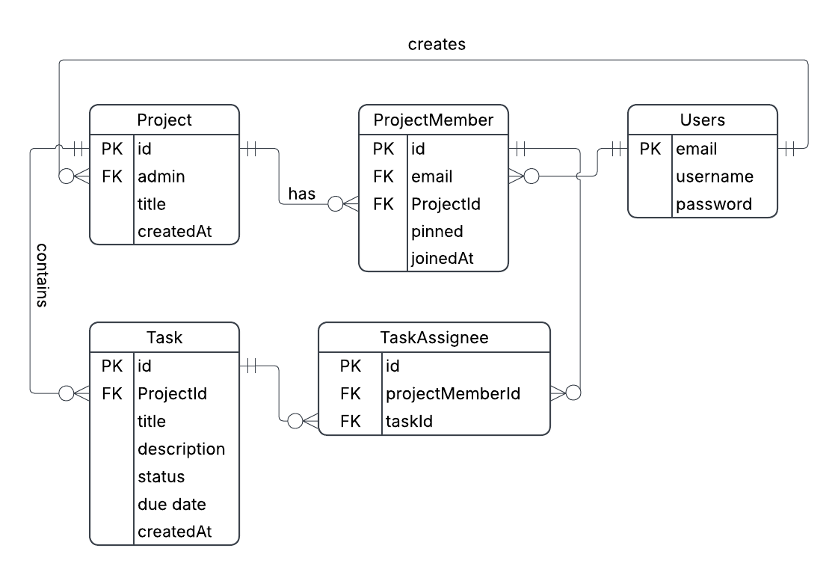

API contract

POST /users signup
URL:
http://localhost:8080/users/signup (Note: we may change it later to/sign-up)

Description:
Create a new authenticated user, a new account.

Body:
{
"email": "HarperLee@example.com",
"username": "Harpy Official",
"password": "how to kill a bird"
}

Response: 201: created
{
"email": "HarperLee@example.com",
"username": "Harpy Official"
}

Possible Errors:
400: Bad request
409: User already exists (conflict)
500: Server error

POST /users/signin
URL:
http://localhost:8080/users/signin (Note: we may change it later to/sign-in)

Description:
Authenticate and sign in users to their accounts. .

Body:
{
"email": "HarperLee@example.com",
"password": "how to kill a bird"
}

Response: 200: Ok
{
"email": "HarperLee@example.com",
"username": "Harpy Official"
}

Possible Errors:
400: Bad request
401: Invalid email or password (Unauthorized)
500: Server error

POST/projects

URL:
http://localhost:8080/projects

Description:
Authenticated users can create a new Project.

Authentication:
Required. Send the JSESSIONID cookie returned by POST /users/signin.

Body:

{
"title": "My first project"
}

Response: 201: Created

{
"id": 1,
"title": "My first project",
"adminEmail": "HarperLee@example.com",
"createdAt": "2026-10-04T15:27:21.5891599"
}

Possible Errors:
401: Authentication required (Unauthorized), missing or expired session cookie
400: bad request (Blank Title)
500: Server error

GET /projects

URL:
http://localhost:8080/projects

Description:
Get all projects the signed-in user is a member of. The user is identified
by the session cookie (JSESSIONID) received on sign-in; no user ID is sent.

Authentication:
Required. Send the JSESSIONID cookie returned by POST /users/signin.

Body:
None

Response: 200: Ok
[
{
“Id”: Integer
"title": "To Kill a Mockingbird Draft",
"adminEmail": "HarperLee@example.com",
"createdAt": "2026-10-04T14:30:00"
}
]
(Returns an empty list [] if the user has no projects.) // I have not test it on real data.

Possible Errors:
401: Authentication required (Unauthorized), missing or expired session cookie
500: Server error

GET /projects/{ProjectID}

URL:
http://localhost:8080/projects/{ProjectID}

Description:
Get projects by ID, the signed-in user is a member of. The user is identified
by the session cookie (JSESSIONID) received on sign-in; no user ID is sent.

Authentication:
Required. Send the JSESSIONID cookie returned by POST /users/signin.

Body:
None

Response: 200: Ok

"id": 2,
"title": "Apollo 11",
"adminEmail": "HarperLee@example.com",
"createdAt": "2026-10-04T23:32:19.400921"
}

Possible Errors:
401: Authentication required (Unauthorized), missing or expired session cookie
404: If the project not found OR or the user is not a member
500: Server error

POST/projects/{projectID}/tasks

URL:
http://localhost:8080/projects/1/tasks

Description:
Authenticated Admin can create a new Tasks.

Authentication:
Required. Send the JSESSIONID cookie returned by POST /users/signin.

Body:

{
"title": "Task-07: Refactor Endpoints",
"description": "Edit the SRS"
}

Response: 201: Created

{
"id": 4,
"title": "Task-07: Refactor Endpoints",
"status": "OPEN",
"description": "Edit the SRS",
"createdAt": "2026-10-06T23:49:04.9450941",
"dueDate": null
}

// Some data can be null !!
Possible Errors:
401: Authentication required (Unauthorized), missing or expired session cookie
400: bad request (Blank Title)
403: Forbidden, when non-admin try
404: When member outside the project try
500: Server error

GET/projects/{projectID}/tasks

URL:
http://localhost:8080/projects/1/tasks

Description:
Authenticated member can see all Project’s Tasks.

Authentication:
Required. Send the JSESSIONID cookie returned by POST /users/signin.

Body: none

Response: 201: Created

[
{
"id": 1,
"title": "Task1: test Tasks",
"status": "OPEN",
"description": null,
"createdAt": "2026-10-05T23:59:08.517705",
"dueDate": null
},
{
"id": 2,
"title": "Task-02: Build home page",
"status": "OPEN",
"description": "Create a dashboard that displays all the User Projects",
"createdAt": "2026-10-06T00:02:13.724436",
"dueDate": "2026-10-07"
},
{
"id": 3,
"title": "Task-03: Build Project scree",
"status": "OPEN",
"description": "Create a dashboard that displays all the Projects tasks and members",
"createdAt": "2026-10-06T00:25:51.413384",
"dueDate": null
}
]

// Some data can be null !!
Possible Errors:
401: Authentication required (Unauthorized), missing or expired session cookie
400: bad request (Blank Title)
404: When member outside the project try
500: Server error

POST/projects/{projectID}/members

URL:
http://localhost:8080/projects/1/members

Description:
Authenticated Admin can create a add new members into the project.

Authentication:
Required. Send the JSESSIONID cookie returned by POST /users/signin.

Body:

{
"email" : "gg@gmail.com"
}

Response: 201: Created

{
"email": "gg@gmail.com",
"userName": "hi",
"projectID": 2,
"projectTitle": "Apollo 11"
}

// Some data can be null !!
Possible Errors:
401: Authentication required (Unauthorized), missing or expired session cookie
400: bad request (Blank Title)
403: Forbidden, when non-admin try
404: When member outside the project or no project with this ID
409: Conflict, when the member is already in the project.
500: Server error

GET/projects/{projectID}/members

URL:
http://localhost:8080/projects/1/members

Description:
Authenticated member can see all Project’s members.

Authentication:
Required. Send the JSESSIONID cookie returned by POST /users/signin.

Body: none

Response: 201: Created

[
{
"email": "HarperLee@example.com",
"userName": "Harpy Official",
"projectID": 2,
"projectTitle": "Apollo 11"
},
{
"email": "gg@gmail.com",
"userName": "hi",
"projectID": 2,
"projectTitle": "Apollo 11"
},
{
"email": "justHater@example.com",
"userName": "hater#1",
"projectID": 2,
"projectTitle": "Apollo 11"
}
]

Possible Errors:
401: Authentication required (Unauthorized), missing or expired session cookie
400: bad request (Blank Title)
404: When member outside the project try
500: Server error

(WIP)

Here is a table of the “MUST” and core features for the App.

num | Method | Path | Story | Who can call it / notes
3 | GET | /api/home | US-2 | Authenticated User
7 | PATCH | /api/projects/{id} | US-22 | Project Admin
12 | GET | /api/projects/{id}/tasks/{taskId} | US-17 | Project Member
13 | PATCH | /api/projects/{id}/tasks/{taskId} | US-14, US-18 | Project Admin / (title, description, due date); assigned Member (description, due date only)
14 | PATCH | /api/projects/{id}/tasks/{taskId}/status | US-21 | Project Admin (any task); assigned Member (own task)
15 | POST | /api/projects/{id}/tasks/{taskId}/assignees | US-12 | Project Admin
16 | DELETE | /api/projects/{id}/tasks/{taskId}/assignees/{email} | US-12 | Project Admin

